Testing for “WhoIS” web service

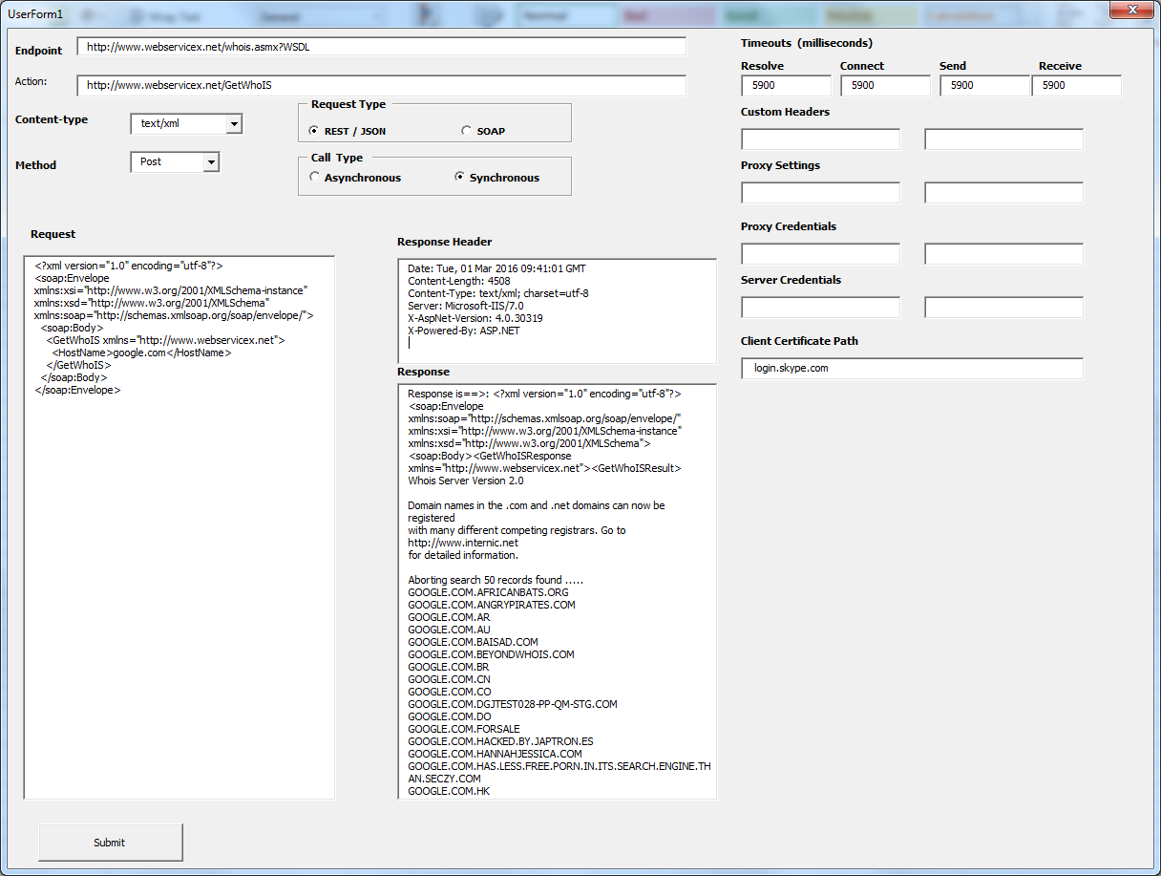

Request XML:

|  |
| --- |
| <?xml version="1.0" encoding="utf-8"?>  <soap:Envelope xmlns:xsi="http://www.w3.org/2001/XMLSchema-instance" xmlns:xsd="http://www.w3.org/2001/XMLSchema" xmlns:soap="http://schemas.xmlsoap.org/soap/envelope/">  <soap:Body>  <GetWhoIS xmlns="http://www.webservicex.net">  <HostName>google.com</HostName>  </GetWhoIS>  </soap:Body>  </soap:Envelope> |

Response Header:

|  |
| --- |
| Cache-Control: private, max-age=0  Date: Tue, 01 Mar 2016 09:38:33 GMT  Content-Length: 4508  Content-Type: text/xml; charset=utf-8  Server: Microsoft-IIS/7.0  X-AspNet-Version: 4.0.30319  X-Powered-By: ASP.NET |

Response XML:

|  |
| --- |
| Response is==>: <?xml version="1.0" encoding="utf-8"?><soap:Envelope xmlns:soap="http://schemas.xmlsoap.org/soap/envelope/" xmlns:xsi="http://www.w3.org/2001/XMLSchema-instance" xmlns:xsd="http://www.w3.org/2001/XMLSchema"><soap:Body><GetWhoISResponse xmlns="http://www.webservicex.net"><GetWhoISResult>  Whois Server Version 2.0  Domain names in the .com and .net domains can now be registered  with many different competing registrars. Go to http://www.internic.net  for detailed information.  Aborting search 50 records found .....  GOOGLE.COM.AFRICANBATS.ORG  GOOGLE.COM.ANGRYPIRATES.COM  GOOGLE.COM.AR  GOOGLE.COM.AU  GOOGLE.COM.BAISAD.COM  GOOGLE.COM.BEYONDWHOIS.COM  GOOGLE.COM.BR  GOOGLE.COM.CN  GOOGLE.COM.CO  GOOGLE.COM.DGJTEST028-PP-QM-STG.COM  GOOGLE.COM.DO  GOOGLE.COM.FORSALE  GOOGLE.COM.HACKED.BY.JAPTRON.ES  GOOGLE.COM.HANNAHJESSICA.COM  GOOGLE.COM.HAS.LESS.FREE.PORN.IN.ITS.SEARCH.ENGINE.THAN.SECZY.COM  GOOGLE.COM.HK  GOOGLE.COM.HOUDA.DO.YOU.WANT.TO.MARRY.ME.JEN.RE  GOOGLE.COM.IS.APPROVED.BY.NUMEA.COM  GOOGLE.COM.IS.NOT.HOSTED.BY.ACTIVEDOMAINDNS.NET  GOOGLE.COM.LASERPIPE.COM.DOMAINPENDINGDELETE.COM  GOOGLE.COM.LOLOLOLOLOL.SHTHEAD.COM  GOOGLE.COM.MAIKO.BE  GOOGLE.COM.MX  GOOGLE.COM.MY  GOOGLE.COM.NOHAREKART.COM  GOOGLE.COM.NS1.CHALESHGAR.COM  GOOGLE.COM.NS2.CHALESHGAR.COM  GOOGLE.COM.PE  GOOGLE.COM.PK  GOOGLE.COM.SA  GOOGLE.COM.SHQIPERIA.COM  GOOGLE.COM.SOUTHBEACHNEEDLEARTISTRY.COM  GOOGLE.COM.SPAMMING.IS.UNETHICAL.PLEASE.STOP.THEM.HUAXUEERBAN.COM  GOOGLE.COM.SPROSIUYANDEKSA.RU  GOOGLE.COM.SUCKS.FIND.CRACKZ.WITH.SEARCH.GULLI.COM  GOOGLE.COM.TESTZZZZ.3000-RI.COM.DELETE-DNS.COM  GOOGLE.COM.TR  GOOGLE.COM.TW  GOOGLE.COM.UA  GOOGLE.COM.UK  GOOGLE.COM.UY  GOOGLE.COM.VABDAYOFF.COM  GOOGLE.COM.VN  GOOGLE.COM.WORDT.DOOR.VEEL.WHTERS.GEBRUIKT.SERVERTJE.NET  GOOGLE.COM.YUCEHOCA.COM  GOOGLE.COM.YUCEKIRBAC.COM  GOOGLE.COM.ZNAET.PRODOMEN.COM  GOOGLE.COM.ZZZZZ.GET.LAID.AT.WWW.SWINGINGCOMMUNITY.COM  GOOGLE.COM.ZZZZZZZZZZZZZ.GET.ONE.MILLION.DOLLARS.AT.WWW.UNIMUNDI.COM  GOOGLE.COM  To single out one record, look it up with "xxx", where xxx is one of the  records displayed above. If the records are the same, look them up  with "=xxx" to receive a full display for each record.  &gt;&gt;&gt; Last update of whois database: Tue, 01 Mar 2016 09:37:39 GMT &lt;&lt;&lt;  For more information on Whois status codes, please visit https://icann.org/epp  NOTICE: The expiration date displayed in this record is the date the  registrar's sponsorship of the domain name registration in the registry is  currently set to expire. This date does not necessarily reflect the expiration  date of the domain name registrant's agreement with the sponsoring  registrar. Users may consult the sponsoring registrar's Whois database to  view the registrar's reported date of expiration for this registration.  TERMS OF USE: You are not authorized to access or query our Whois  database through the use of electronic processes that are high-volume and  automated except as reasonably necessary to register domain names or  modify existing registrations; the Data in VeriSign Global Registry  Services' ("VeriSign") Whois database is provided by VeriSign for  information purposes only, and to assist persons in obtaining information  about or related to a domain name registration record. VeriSign does not  guarantee its accuracy. By submitting a Whois query, you agree to abide  by the following terms of use: You agree that you may use this Data only  for lawful purposes and that under no circumstances will you use this Data  to: (1) allow, enable, or otherwise support the transmission of mass  unsolicited, commercial advertising or solicitations via e-mail, telephone,  or facsimile; or (2) enable high volume, automated, electronic processes  that apply to VeriSign (or its computer systems). The compilation,  repackaging, dissemination or other use of this Data is expressly  prohibited without the prior written consent of VeriSign. You agree not to  use electronic processes that are automated and high-volume to access or  query the Whois database except as reasonably necessary to register  domain names or modify existing registrations. VeriSign reserves the right  to restrict your access to the Whois database in its sole discretion to ensure  operational stability. VeriSign may restrict or terminate your access to the  Whois database for failure to abide by these terms of use. VeriSign  reserves the right to modify these terms at any time.  The Registry database contains ONLY .COM, .NET, .EDU domains and  Registrars.  </GetWhoISResult></GetWhoISResponse></soap:Body></soap:Envelope> |

Source:

<http://www.webservicex.net/New/Home/ServiceDetail/52>